**MENTOR MANAGEMENT WEB APP**

**ARCHITECTURE DESCRIPTION**

**Chapter 1**

**Introduction**

The purpose of the requirements specification document is to gather together all the different aspects of the proposed Mentor Management System to give detailed in-sight into the requirements of the system. The document provides both a high-level overview of product features as well as defining the proposed system in depth.

**Overview**

The proposed system’s aim is to help university find suitable mentors who are either professionals in Gauteng or students. The system will operate as the Mentor Management System’s (MMS) digital replacement for current manual and unreliable system of operation.

There are two primary users of the system - the mentor and the mentee. There is one secondary user - the administrator of the mentor management system.

There are many benefits to the system the primary of which is that users do not have to physically locate and go to the administrator’s office to get or to be a mentor and that the administrator doesn’t have to manually match mentors to mentees.

Some of the secondary benefits that can be realized is the ability for mentors to keep track of the Mentors that register as well as coordinate the success programmes. To allow for mentees and mentors to edit their details and be matched with preferred mentors and mentees.

The risks that need to be taken into consideration are in level of High to Low. Some of the serious ones is information security and data loss. We also need to take a serious look at component damage over time and the influx of users at any time. This means the system needs to be able to handle multiple users at any given time without latency.

Successful and effective risk management is the basis of successful and effective IT security. Due to the reality of limited resources and nearly unlimited threats, a reasonable decision has been made concerning the allocation of resources to protect systems that will be introduced.

**Glossary**

**Mentor** – an experienced and trusted adviser

**Mentee** – a person who is advised by a mentor

**Pair** – A mentor and his/her mentee

**MMS** ­ ­- Mentor Management System; Proposed system.

**Mentor Management Scope**

This system is web application that will be able to register a mentor, requiring their demographic data, contact information, professional history to date, qualities of a preferred mentee and etc. System will also register a mentee requiring their demographic data, contact information, tertiary education details, brief description of themselves, preferred mentor and etc. This system will then match mentee with 1 or more mentors that more or less fits his/her criteria ordered by likelihood of preference. The mentee will then be able to “request” a mentor thereafter the mentor can then view the mentees profile which includes his/her contact details and can then choose to contact them with a response on whether or not they are willing to mentor the mentee. A mentor can choose to be inactive, not be visible in mentee’s “search results”, after they have found one or more mentees or at any given time. After a mentor registers to the system, an administrator will contact them and somehow verify the data given by the mentor before they are officially in the system. When a mentor chooses to mentor a student, they both have to set their status to paired and the student will be able to rate the mentor. This rating is viewed by the mentees when viewing a profile. A mentor can be a working individual and/or a student doing their 2nd year or up and the mentee is restricted to any university student.

This app is for university students and professional individuals. The functionalities will differ depending on who the user is, which is determined during registration. The system is facilitated by an administrator, who has access to all data stored in the system, verifies mentees and handles/records system reviews.

This system does not yet provide a platform for users to communicate.

**Chapter 2**

**Stakeholders and concerns**

**2.1 Stakeholders**

**End User**

These are Mentor, Mentee and Administrator. Mentee wants to search and find a mentor.

**Front End Developer**

Programmer who focuses on writing code for the display to the user.

**Back End Developer**

Programmer who creates the logical **back**-**end** and core computational logic of a website.

**Business Analyst**

Analyzes an organization or **business** domain (real or hypothetical) and documents its **business** or processes or systems, assessing the **business** model or its integration with technology.

**Systems Analyst**

Analyzes a complex process or operation in order to improve its efficiency, especially by applying a computer system.

**Software Testers**

A software tester is involved in the quality assurance stage of software development and deployment. They conduct automated and manual tests to ensure the software created by developers is fit for purpose. Software testing involves the analysis of software, and systems, to avert risk and prevent software issues.

**Database Administrators**

A **database administrator** (**DBA**) is responsible for the performance, integrity and security of a **database**. They will also be involved in the planning and development of the **database**, as well as troubleshooting any issues on behalf of the users.

**Developer Manager**

The Applications Development Managers works with the CIO and senior management to determine systems development strategy and standards.

**User Experience Specialist**

They design and execute usability studies and other **user** research, utilizing their broad knowledge of **user experience** and methodological expertise. As the project evolves, the UX **Specialist** will conduct **user** testing and other **user**-facing activities to validate the design, interaction and content.

**Use Cases**

|  |  |  |
| --- | --- | --- |
| USER | FUNCTIONAL REQUIREMENTS | Use Case |
| General | System must allow user to register and specify the type of user (Mentor/Mentee). | Register User |
| System must allow user to login using a username and password | Login User |
| System must allow user to deactivate their account | Archive User |
| System must allow user to update their profile. | Update Profile |
| Mentee | System must allow mentee to fill out a form detailing preferred mentor. | Create Preferences List |
| System must allow mentee to update their mentor preferences. | Update Preferences List |
| System must allow mentee to search for a mentee; provide filtered suggestion based on preferences. | Search Mentor |
| System must allow mentee to view a mentor’s profile (including rating). | View Mentor Profile |
| System must allow mentee to request a mentor’s mentorship. | Request Mentor |
| System must allow mentee rate a mentor; provided the two are paired therefore if mentor has accepted the request. | Rate Mentor |
| *System must allow mentee to mentor’s contact details; provided mentor has accepted the request. | *View Mentor Contact Details |
| Mentor | System must allow mentor to receive request for mentorship. | View Request |
| System must allow mentor to view a mentee’s profile | View Mentee Profile |
| System must allow mentor to accept a request; pairing the two. | Accept Request |
| Administrator | System must allow admin to verify new mentors. | Update Mentor Verification |
| System must allow admin to view mentor ratings. | View Mentor Rating |
| System must allow admin to deactivate a mentor’s or mentee’s account. | Archive User |

**Chapter 3**

**Viewpoints+**

**Logical view**

This view shows the structure the system in a logical and hierarchical manner including all the components.

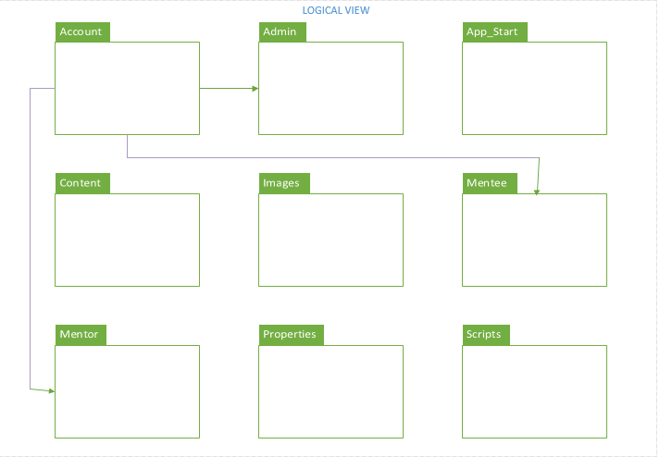

**Physical View**

The system representation at the physical level, the deployment diagram is used to show how hardware component are connected 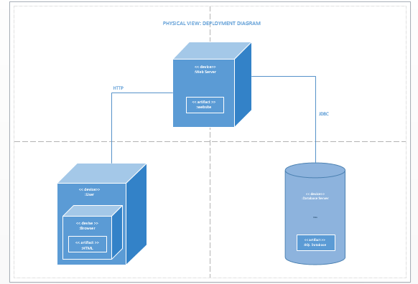

.

**Development View**

A view that shows how the components are related and the services they provide to each other including update and implementation.

